COURSE NAME:
Introduction To Software Engineering
COURSE CODE:
IS1103-1
ASSIGNMENT NAME:
SOFTWARE DEVELOPMENT LIFECYCLE(SDLC) ANALYSIS OF ONLINE FOOD DELIVERY SYSTEM
STUDENT NAME:
ADARSH M JAIN
STUDENT USN:
NNM24IS008
SEMESTER AND SECTION:
IV-A
DEPARTMENT:
INFORMATION SCIENCE AND ENGINEERING
INSTITUTION NAME:
NITTE MAHALINGA ADYANTHAYA MEMORIAL INSTITUTE OF TECHNOLOGY
ACADEMIC YEAR:
2025-2026
INSTRUCTOR NAME:
DR. JASON ELROY MARTIS
DATE OF SUBMISSION:
16TH FEBRUARY 2026

ABSTRACT
This report explores three major Software Development Life Cycle (SDLC) models Waterfall, Incremental, and Spiral by applying them to the development of an Online Food Delivery System. Today’s food delivery platforms operate in fast-changing environments where customer expectations, restaurant requirements, delivery logistics, payment methods, and market competition constantly evolve. Because of this dynamic nature, choosing the right development model becomes a practical engineering decision rather than just a theoretical concept.
The report discusses how each SDLC model manages both functional requirements (such as placing orders, tracking deliveries, and processing payments) and non-functional requirements (such as performance, scalability, security, and reliability). It also examines how these models handle requirement changes, risk management, development time, and overall cost. Key system features including order processing, real-time tracking, restaurant menu management, and coordination between customers, restaurants, and delivery partners are analyzed to understand how different models support system growth and complexity.
To demonstrate the requirements engineering process, a simplified requirements specification is included, along with a validation plan and discussion of possible technical and operational challenges. The main goal of this study is to connect software engineering theory with real-world system development. Additionally, the report outlines version control practices and repository workflows to reflect how documentation and collaboration are handled in actual software projects. Overall, this study provides a clearer understanding of how theoretical SDLC concepts are practically applied in building and maintaining large-scale, real-time service platforms like an Online Food Delivery System.

TABLE OF CONTENTS

GITHUB REPO LINK……………………………………………………………………….2
INTRODUCTION……………………………………………………………………………4
KEY COMPONENT…………………………………………………………………………5
SYSTEM OVERVIEW………………………………………………………………………6
COMPARATIVE ANALYSIS SDLC MODELS…………………………………………….7
1.Waterfall Model…………………………………………………………………………8-9
2.Incremental Model……………………………………………………………………10-11
3.Spiral Model…………………………………………………………………………...12-14
COMPARISON TABLE………………………………………………………………….15
EXPLANATION ABOUT THE COMPARISON TABLE……………………………16-17
REQUIREMENTS VALIDATION STRATEGY………………………………………..18
CHALLENGES IN REQUIREMENTS VALIDATION ………………………………..18
REFERENCES…………………………………………………………………………...19
DECLARATION OF ACADEMIC INTEGRITY………………………………………..20

INTRODUCTION
In today’s world, software systems are rarely built in a perfectly straight line from start to finish. Most real-world applications grow step by step and continue to evolve based on user feedback, business needs, competition, and new technologies. Because of this, software engineering is not just about programming it is also about choosing the right development approach. The Software Development Life Cycle (SDLC) provides a structured way to plan, design, develop, test, and maintain software systems efficiently[1].
Different SDLC models follow different working styles. Some assume that all requirements are clearly known at the beginning and will not change much during development. Others are more flexible and allow changes, feedback, and risk evaluation throughout the process. Selecting the wrong model can lead to delays, increased costs, unmanaged risks, and a system that does not fully meet user expectations[7],[3]. Therefore, understanding how different SDLC models perform in real-world situations is very important.
For this study, an Online Food Delivery System is chosen as the case study. Food delivery platforms are widely used today and involve multiple stakeholders such as customers, restaurants, delivery partners, and administrators. These systems are not simple applications; they include several interconnected modules like user registration, restaurant and menu management, cart and order processing, online payment integration, real-time delivery tracking, notifications, and customer support. Since these modules depend on one another, any change in one part of the system can affect other parts[1].
Online food delivery platforms operate in a highly dynamic environment. Customer preferences change frequently, restaurants update menus and prices, new offers and discounts are introduced regularly, and delivery logistics must adapt to traffic conditions and peak hours. Additionally, the system must handle high user traffic during weekends, festivals, and promotional events without slowing down. Security, performance, and scalability requirements also continue to grow over time[2],[4].
This report compares three major SDLC models Waterfall, Incremental, and Spiral and analyzes how suitable each model is for developing and maintaining an Online Food Delivery System. The comparison focuses on how each model handles requirements, manages risks, supports changes, and deals with time and cost constraints. A simplified requirements document and a validation strategy are also included to show how theoretical SDLC concepts are applied in practical software development[1],[2].
KEY COMPONENTS OF ONLINE FOOD DELIVERY SYSTEM

An Online Food Delivery System is a digital platform that connects customers, restaurants, and delivery partners through mobile apps and websites. Unlike a single restaurant website, this system supports multiple restaurants on the same platform, allowing each to manage its own menu, pricing, and offers. Since many users place orders at the same time—especially during peak hours—the system must handle heavy traffic efficiently without slowing down or failing[1],[2].
The platform consists of several interconnected modules. It allows users to register, log in, browse restaurants, search for food items, and place orders. Restaurants can update menus and manage incoming orders, while customers can add items to their cart, choose payment methods, and track deliveries in real time. The system also sends notifications and collects ratings and feedback. Although each module performs a specific function, they are closely connected, meaning an issue in one module (such as payment failure) can affect the entire process[6].
The system operates in a constantly changing environment. Restaurants frequently update menus and prices, new discounts are introduced, and delivery charges may vary[1]. During weekends or festivals, user traffic increases significantly, making performance and scalability very important.
Different users have different expectations: customers want fast delivery and secure payments, restaurants want efficient order management, and delivery partners need clear instructions. Managing all these requirements makes the system complex. Because of its real-time operations, frequent updates, and multiple stakeholders, an Online Food Delivery System is a suitable example for analyzing and comparing different SDLC models[1],[3].

SYSTEM OVERVIEW – ONLINE FOOD DELIVERY SYSTEM
Three different Software Development Life Cycle (SDLC) models are discussed:
1. Waterfall Model
The Waterfall model is a traditional and structured approach to software development where the process flows step by step in a fixed sequence. Each phase must be completed before moving to the next one. The stages do not overlap, and once a phase is finished, it is generally not revisited. The development process moves in one direction only — from top to bottom — similar to the flow of a waterfall[2],[3].
This model is suitable when the system requirements are clearly defined at the beginning and are not expected to change frequently. In the case of an Online Food Delivery System, the Waterfall model can be applied when the core functionalities (such as user registration, menu browsing, order placement, and payment processing) are well understood and stable[1],[7]. The main stages followed in the Waterfall model are:
- System and Software Requirements
- Analysis
- Design
- Coding (Implementation)
- Testing
- Operations (Deployment &Maintenance)
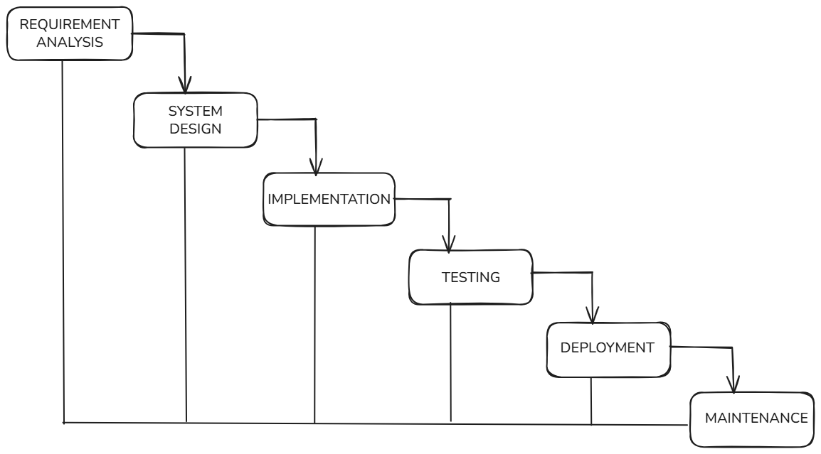
Figure 1: Waterfall Model for Online Food Delivery System
HOW AN ONLINE FOOD DELIVERY SYSTEM IS DEVELOPED USING THE WATERFALL METHOD

In this first stage, the development team discusses the system with customers, restaurant owners, delivery partners, and managers. They identify and finalize features such as login, menu browsing, food ordering, payment processing, tracking, and reviews.
All requirements are clearly documented before moving forward, because in the Waterfall model, changes later can be difficult and expensive [1], [6].

Phase 2: System and Software Design
Once requirements are finalized, the team plans how the system will function. They design the database, system architecture, and application screens.
Modules such as order management, payment gateway integration, and delivery tracking are carefully structured at this stage to ensure everything is clearly defined before coding begins [1].

Phase 3: Implementation and Unit Testing
After design is completed, developers begin coding the system. Each module is developed separately and tested individually (unit testing) to confirm it works correctly before being combined with other modules [2].

Phase 4: Integration and System Testing
In this phase, all modules are integrated into one complete system. The team performs system testing to ensure ordering, payment, tracking, and overall performance work properly.
Special attention is given to system performance during peak hours, such as lunch or dinner time, to ensure reliability [8], [2].

Phase 5: Deployment and Maintenance
Finally, the system is deployed for users. After launch, the team monitors performance, fixes bugs, and makes minor improvements.
However, in the Waterfall model, making major changes after deployment can be costly and time-consuming because earlier phases are not easily revisited [1], [2].

2. Incremental Model
The Incremental Model is a software development approach where the system is built in small, manageable parts instead of creating everything at once. The project is divided into several stages, and each stage adds new features to the previous working version. After completing each part, it is properly tested and then delivered before moving to the next increment [1], [2].
This method allows users to start using the basic features early, even while the system is still being improved. It also makes it easier to handle changes, fix issues, and add improvements later without affecting the entire system. Because development happens step by step, risks are reduced and feedback can be used to make the next version better [1], [7].

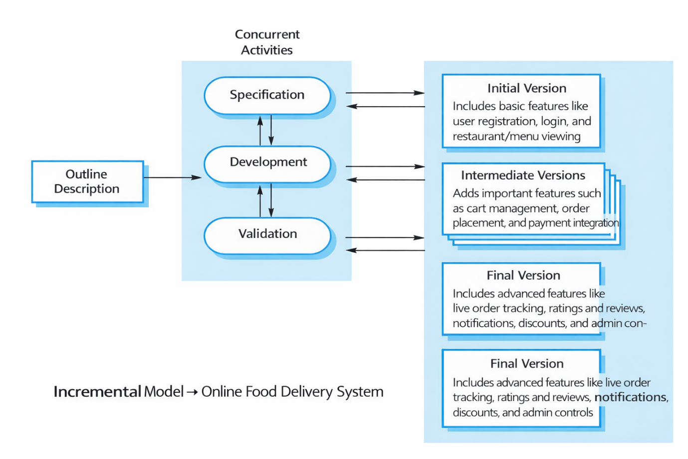

Figure 2: Incremental Model for Waterfall Model for Online Food Delivery System

HOW AN ONLINE FOOD DELIVERY SYSTEM IS DEVELOPED USING THE INCREMENTAL MODEL
An Online Food Delivery System keeps expanding as more restaurants join and new features are introduced. The Incremental Model supports this growth by developing the system step by step. Instead of building everything at once, features are added gradually. This reduces risk and allows improvements based on user feedback after each release [6], [2].

Phase 1: First Increment
In the beginning, only the basic features are developed. Users can register, log in, and browse restaurants and menus. Restaurants can also sign up on the platform.
This simple version is tested and released early so that real users can start using it and provide feedback. Early delivery of a working system is one of the key advantages of the Incremental Model [2].

Phase 2: Second Increment
In the next stage, additional features such as the cart system and basic order placement are added. Users can now select items, add them to their cart, and place orders.
These new features are tested carefully to ensure they work smoothly with the existing system. Each increment builds upon the previous one without disturbing completed functions [1].

Phase 3: Third Increment
Once ordering works properly, online payment options are introduced. The system integrates secure payment gateways, and users receive confirmation after successful transactions.
At this stage, the platform begins functioning like a complete food delivery service, offering both ordering and payment capabilities [1], [2].

Phase 4: Final Increments
Finally, advanced features such as live order tracking, delivery management, ratings and reviews, promotional offers, notifications, and admin controls are added.
Each feature is tested before release. This gradual and controlled development process helps the system grow smoothly, reduces major risks, and ensures a better user experience [1], [2].

3. Spiral Model
The Spiral Model is a software development approach where the system is built in repeated cycles, also called rounds. In each cycle, the team first plans what needs to be done, then identifies possible risks, develops the required features, and tests them carefully. After completing one round, the team reviews the results and begins the next round with improvements and a clearer understanding of the system [1], [2].
This model is especially useful for complex systems like an Online Food Delivery System. Since such platforms must handle secure payments, high user traffic, and real-time tracking, risks are always present. The Spiral Model focuses strongly on identifying and reducing these risks at every stage, which helps in building a more stable, secure, and reliable system over time [3], [5].

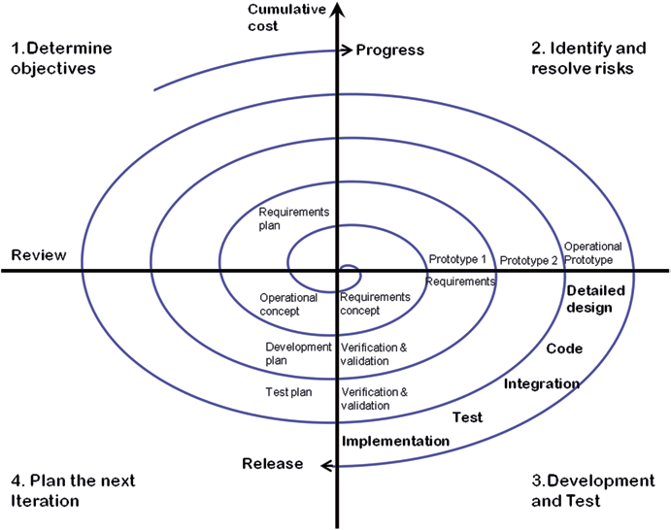

Figure 3: Spiral Model for Online Food Delivery System

HOW AN ONLINE FOOD DELIVERY SYSTEM IS DEVELOPED USING THE SPIRAL MODEL
An Online Food Delivery System faces many challenges, such as handling heavy traffic during peak hours, ensuring secure payments, and managing delivery delays. The Spiral Model helps manage these challenges in a structured and risk-focused way. It develops the system in repeated cycles (or rounds), and in each cycle, risks are identified, analyzed, and reduced before moving forward [1], [2], [3].

Phase 1: Planning and Understanding Requirements
In the first phase, the development team discusses and identifies what the system should include. Core features like user registration, restaurant listing, menu browsing, cart management, and order placement are planned.
At the same time, the team thinks about possible risks, such as high user traffic during peak hours or payment security issues. A basic plan or early prototype is prepared to clearly understand system goals before proceeding [1], [3].

Phase 2: Risk Analysis and Design
In this phase, the main focus is risk analysis. The team carefully studies possible problems. For example, online payments might fail, personal data must be protected, or servers may crash during busy hours.
Based on this analysis, the system is designed to reduce these risks. Secure payment gateways, data encryption, and scalable server architecture may be selected to improve safety and performance [2], [3].

Phase 3: Development and Testing
After planning and risk evaluation, the team begins development. Features such as search options, cart functionality, payment processing, and delivery tracking are built step by step.
Each feature is tested immediately after development. If any issues are found, they are corrected early. This continuous testing improves system quality and reduces major failures later [1], [2].

Phase 4: Review and Improvement
Once one cycle is completed, the system is reviewed. Feedback is collected from customers, restaurant partners, delivery staff, and administrators.
Based on the feedback, improvements and new features are planned for the next cycle. The process repeats until the system becomes stable, secure, efficient, and ready for large-scale use [1], [3].

COMPARISON TABLE

Aspect | Waterfall Model | Incremental Model | Spiral Model
Functional Requirements | All features are decided at the beginning and usually cannot be changed later. | Features are added step by step in different versions. | Features are reviewed and improved in every cycle.
Non-Functional Requirements | Planned early, but difficult to improve later. | Improved gradually with each new release. | Carefully checked and refined in every round.
Risk Management | Very little attention is given to risks. | Some risks are handled as new increments are developed. | Strong focus on identifying and reducing risks in every cycle.
Change Handling | Making changes later is difficult and expensive. | Changes are easier to add between increments. | Changes are expected and managed continuously.
Time Constraints | Takes more time before users see the complete system. | Basic features are delivered quickly, so users see results earlier. | Takes more time because each cycle includes risk analysis and review.
Cost Constraints | Lower cost at the beginning, but expensive if changes are needed later. | Cost is divided across multiple stages. | Higher cost due to continuous risk analysis and repeated cycles.
Suitability for Online Food Delivery System | Not very suitable if requirements keep changing. | Good for systems that grow gradually with new features. | Best for large, complex systems where security and performance are critical.

The above table has been taken reference from [1], [3],[5].

EXPLAINATION ABOUT THE COMPARISON TABLE

When developing an Online Food Delivery System, choosing the right software development model is very important. Different models handle features, risks, and changes in different ways [1], [2].

Functional Requirements
In the Waterfall model, all features are finalized at the beginning of the project. This can be limiting because food delivery platforms often need to introduce new features such as promotional offers, updated payment methods, or improved tracking systems [1].
The Incremental model develops the system in smaller parts. Features are added step by step, which makes it easier to introduce new functions over time [2].
The Spiral model improves the system in cycles. In each cycle, features are reviewed, tested, and refined. This approach works well for complex functions like real-time order tracking or secure payment processing [1], [3].

Non-Functional Requirements
In the Waterfall model, performance, security, and reliability are planned early in the project. However, making improvements later can be difficult and costly [2].
The Incremental model allows performance and security to improve gradually with each release, making it more adaptable [1].
The Spiral model evaluates and enhances non-functional aspects such as speed, safety, and reliability in every cycle, ensuring continuous improvement [3].

Risk Management
Waterfall gives limited attention to risk once development begins [1].
The Incremental model reduces risk by building and testing the system in smaller sections, allowing problems to be detected earlier [2].
The Spiral model strongly focuses on identifying and reducing risks at every stage, making it suitable for large and complex systems [3].

Change Handling
Changes are difficult and expensive to implement in the Waterfall model because everything is planned at the start [2].
The Incremental model allows changes between different versions, offering more flexibility [1].
The Spiral model expects changes and manages them continuously through repeated evaluation and refinement [3].

Time and Cost
Waterfall usually takes longer to deliver a fully working system, and any changes can increase cost significantly [1].
The Incremental model delivers useful features earlier and spreads development costs over time [2].
The Spiral model may require more time and cost due to repeated analysis, risk assessment, and testing, but it often results in a more stable system [3].

Overall Suitability
For an Online Food Delivery System, the Incremental and Spiral models are generally more suitable. They support system growth, flexibility, and better risk management. The Waterfall model is less suitable because of its rigid and sequential structure [1], [2], [3].

REQUIREMENTS VALIDATION STRATEGY
Requirements validation means checking whether the written requirements are clear, correct, and useful before starting development [1], [2]. It makes sure the Online Food Delivery System is built according to the real needs of customers, restaurants, and delivery partners.
First, the requirements are discussed with all stakeholders. Customers, restaurant owners, delivery staff, admins, and developers review them to confirm that everything is properly included [1]. Feedback is collected, and any unclear points are corrected [2].
Next, simple meetings and review sessions are conducted. Basic prototypes or diagrams are shown to explain how the system will work [2], [7]. This helps identify missing features or mistakes early.
Finally, requirements are reviewed again after small updates or new features are added. This ensures that changes do not affect existing functions like ordering or payment [1], [8]. Once confirmed, the requirements are finalized for development.

CHALLENGES OF REQUIREMENT VALIDATION
Validating requirements is not always easy, especially for a large and growing food delivery platform [1], [2].
One challenge is changing needs. Customer preferences, restaurant options, and delivery methods keep changing, making it hard to finalize requirements [2].
Another challenge is having many stakeholders. Customers, restaurants, delivery partners, and admins may all have different expectations [1], [7].
Unclear feedback can also create confusion. Sometimes users cannot clearly explain what they need, which may lead to misunderstandings [3].
Lastly, time pressure makes validation difficult. Teams often work under strict deadlines, which may lead to rushed validation [1], [2].

REFERENCES

[1] Pressman, R. S., & Maxim, B. R. (2019). Software Engineering: A Practitioner’s Approach (9th ed.). McGraw-Hill Education.
[2] Sommerville, I. (2016). Software Engineering (10th ed.). Pearson Education.
[3] Kotonya, G., & Sommerville, I. (1998). Requirements Engineering: Processes and Techniques. John Wiley & Sons.
[4] Royce, W. W. (1970). “Managing the Development of Large Software Systems.” Proceedings of IEEE WESCON. (Waterfall Model concept).
[5] Boehm, B. W. (1988). “A Spiral Model of Software Development and Enhancement.” Computer, 21(5), 61–72. (Spiral Model).
[6] Larman, C., & Basili, V. R. (2003). “Iterative and Incremental Development: A Brief History.” IEEE Computer, 36(6), 47–56. (Incremental Model).
[7] Wiegers, K. E., & Beatty, J. (2013). Software Requirements (3rd ed.). Microsoft Press.
[8] ISO/IEC/IEEE 29148:2018. Systems and Software Engineering — Life Cycle Processes — Requirements Engineering. International Organization for Standardization.

DECLARATION OF ACADEMIC INTEGRITY
I hereby declare that this assignment is my original work and has not been copied or plagiarised from any source. All references and resources used have been properly cited. Any ambiguities will lead to forfeiting my marks.

Student Signature: Submission Date:
16th February 2026
